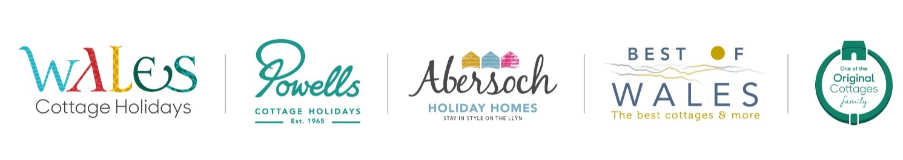

Property Recruiter - Anglesey

A little bit about us in Wales.…

Wales Cottage Holidays, Best of Wales, Abersoch Holiday Homes and Powells Cottage Holidays are four market leading holiday letting brands in Wales and are all part of the largest independent cottage agency in Wales. Established for more than 25 years, we have offices in Abercynan, Abersoch, Cemaes, Newton and Saundersfoot, and offer marketing, sales and property management for more than 1,000 properties throughout Wales.

And we are part of a family too, The Original Cottages Family…

Wales Cottage Holidays, Best of Wales, Abersoch Holiday Homes and Powells Cottage Holidays are four brands of a UK family of over 25 locally managed brands owned by the Original Cottages Company. Being part of this family gives us a very special offering of being both local and national. We really have the best of both worlds, our local teams have local knowledge, and with Original Cottages we have a national audience and refined expertise.

Having our local brands means we can give that local, personal touch to our homeowners and holidaymakers alike. We believe this gives the best of both worlds and is unique in our industry.

We foster universally high standards and take an ethical approach when dealing with our employees. We believe in playing to people's strengths and are proud of our reputation for flexibility and fairness as an employer, providing a professional, innovative and fun place to work. This is reflected in the fact that many of our employees are long-serving and thus very experienced.

We take delight in seeing our employees develop and grow within the business. We are proud to be a true family business with a strong set of values which guide and inform the way we work.

We are;
- Family owned | - Honest | - Flexible
- Local | - Customer focused | - Progressive
- Friendly  - Reliable | - Innovative | - Fun

Job Description - What’s the job all about then? Overview
This is a really exciting job; if you love property, people and working in a fun and ambitious team then read on! This role is an integral part of the recruitment team in Wales, with the opportunity to help shape the future of the business and development of the portfolio – both new and existing.

The ideal candidate

We are looking for a fun, friendly, enthusiastic person with a can-do attitude to join the Property Recruitment Team. You will be confident, motivated and a self-starter with a view of growing our Wales Cottage Holiday and Best of Wales Anglesey portfolio. A confident personality is imperative as you will often be the first person that our homeowner’s contact during their journey from idea to reality. In addition to homeowners you will also be a confident networker, comfortable working existing and new contacts and leads. You will be happy working individually or as part of a team. Attention to detail is vital as is an empathetic manner when liaising with homeowners and it goes without saying that you need to be well organised, with great time management skills. Excellent computer skills, a good standard of written communication and a friendly and helpful telephone manner are all important parts of a fantastic role.

- You will need a flair for property, possibly with current experience in this field, and also some sales experience.
- You will be meeting prospective owners and ‘selling’ Wales Cottage Holiday and Best of Wales to them, so you will need to be confident and persuasive whilst adapting to individual personalities and customer expectations.
- Our recruiting numbers each year are going from strength to strength and you will be expected to participate towards an annual recruitment target.
- You will also need to be computer literate with good Microsoft Skills, have good admin and telephone skills and enjoy talking to people from all walks of life.
- You will need to be able to communicate both written and verbally in both Welsh and English
- As part of your training you will be shown our TABS booking system.

Responsibilities & Tasks

- Carry out homeowner visits in all areas of Anglesey and at time along the North Wales coast dealing with initial enquiries professionally and working with potential homeowners to meet our company standards for holiday lets to ensure properties maximise bookings and reach quality guidelines.
- Contribute to plans for business growth through property recruitment and retention within Anglesey.
- A key representative of ‘Anglesey’, develop local relationships and ensure visibility locally.
- Identify ways to develop new business and opportunities to generate enquiries.

- Work with the Wales marketing team to plan and implement advertising and promotional strategy and activities related to recruiting and retaining properties.
- Seek and continuously develop knowledge and information about competitor activity, pricing and tactics.
- Build a business network and community presence to increase brand awareness.
- Set up properties on the website & through TABS adhering to our current brand processes including relevant knowledge and application of property letting legislation.
- Build relationships with local property developers and estate agents in Anglesey.
- Target independent property owners to introduce Wales Cottage Holidays and Best of Wales, coming up with flexible arrangements to gain additional properties for the Wales portfolio.
- Work with the Grading Team to ensure the TOCC grading scheme is implemented and effective for all Anglesey properties.
- Be proactive in suggesting improvements to the recruitment process.
- Be a proactive member of the Wales Recruitment Team, working together to develop and progress recruitment across Wales.

Working Hours
- We offer attractive working conditions and a very strong team working ethos in which people are encouraged to feel part of “the family”.
- The hours of work will be 37.50 hours a week working primarily 5 days Monday – Friday with some hours occasionally over weekends and evenings.
- 22 days holiday a year (plus bank holidays) and nobody works on their birthday! The longer you work with us then the better holiday and conditions you receive – we value longevity and loyalty.
- We operate a company contributory pension scheme.
- In a steadily growing company such as this, the career opportunities are there for further advancement into any part of the business – promoting from within being a major part of our business philosophy and values.

Closing Date Wednesday 4th September 2019

Interested? This is how to apply…

Please send a CV and covering letter (this is important to us) with a little bit about you and why the job appeals to you. This should be addressed for the attention of Jane Grant and sent to us using the contact details below. The closing date is Wednesday 4th September but don’t delay as we encourage early applications.

First interviews week commencing 10th September 2019.

We look forward to hearing from you soon.

Email Address – j.grant@abersochholidayhomes.co.uk

Telephone Number – 01758 740992.

Office Address – Wales Cottage Holidays, Bear House, Bear Lanes, Newtown, Powys, SY16 2QZ

